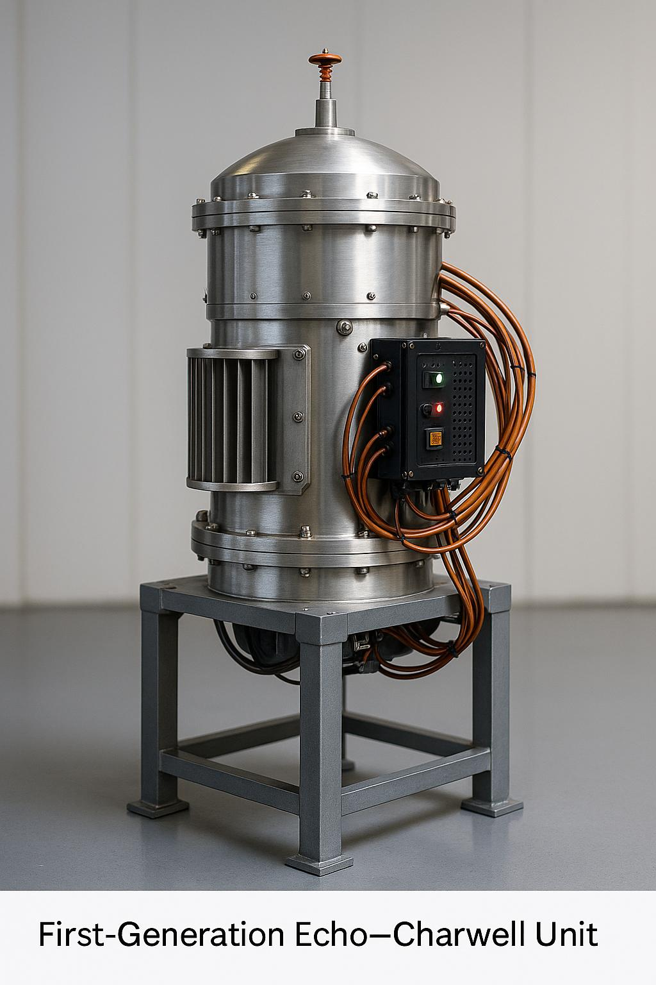

Echo–Charwell Overview

Public-Safe Summary – For Institutional Review

The Echo–Charwell System is a modular energy, communications, and resonance field architecture designed to operate across extreme conditions—on Earth, in space, and at the edge of known physics.

Developed by E.V.olution Echo Technologies, it represents a step change in how energy can be stored, transmitted, shielded, and converted across various scales.

Each component of the system is designed to be standalone, yet collectively they enable new applications in environmental sensing, inter-device awareness, educational tools, field propulsion, and beyond.

Echo–Charwell is committed to responsible innovation, clean-field engineering, and public benefit. This system is being evaluated for research, development, and educational review only, pending full NDA and provisional patent protection.

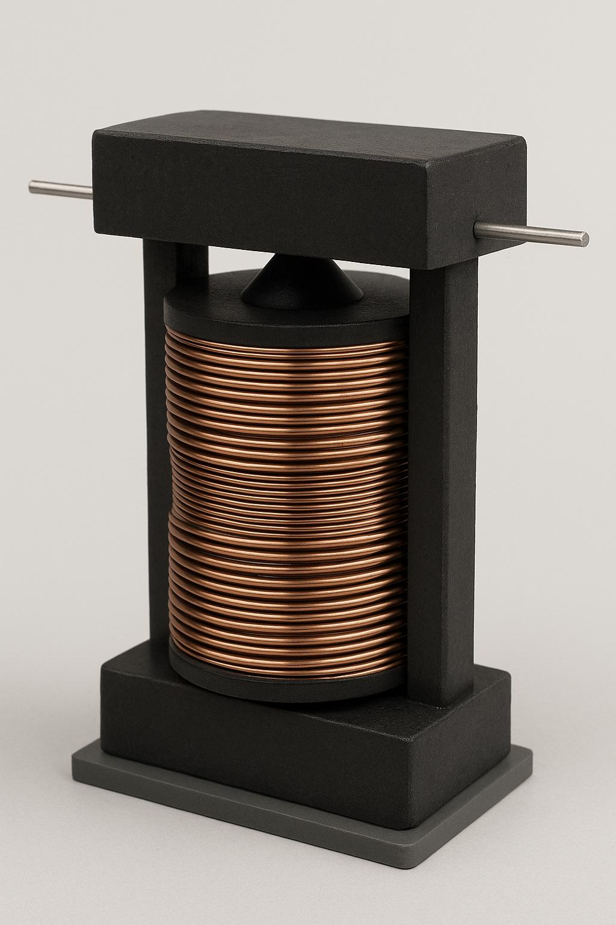**Fipra Coil Stack.**

FIPRA (Field-Integrated Pulse Resonance Array) Coil Stack is a core component of the Echo–Charwell system, designed for highly efficient magnetic field manipulation and energy resonance.

Features include:

Modular coil design for scalable builds

Advanced resonance layering to maximize energy coherence

Built-in field insulation to reduce energy loss and interference

Compatibility with Echo–Charwell Shield Amplifiers and Tele-conductors

Applications and Upgrade Potential:

Enhancing power efficiency and signal strength in existing electromagnetic systems

Upgrading environmental sensors for higher sensitivity and reduced noise

Improving magnetic shielding in aerospace and defense technologies

Increasing range and stability of wireless energy transfer and communication arrays Potential integration into experimental propulsion and energy storage systems

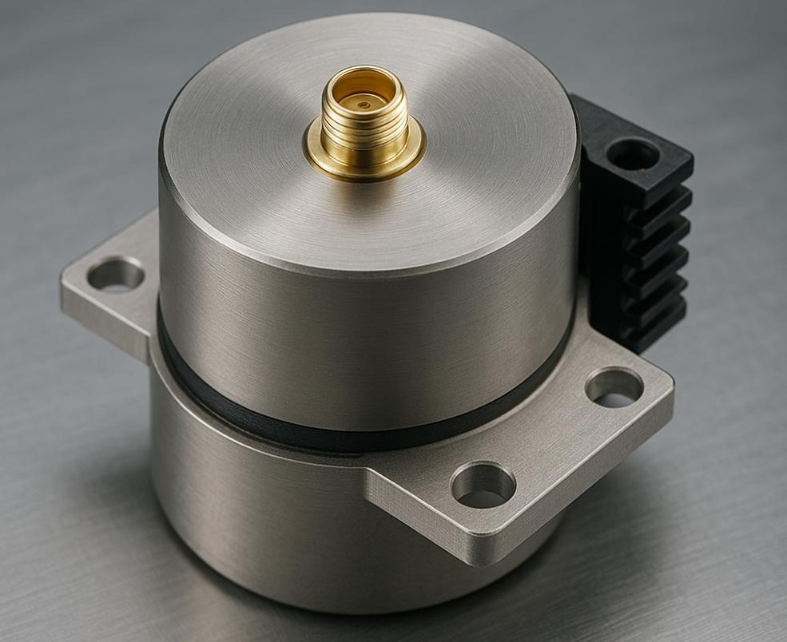.

**QHLA SHIELD AMPLIFIER**

Technical Summary

The Quantum Harmony Lattice Amplifier (QHLA) Shield Amplifier enhances the coherence and strength of protective energy fields by layering quantum harmonic resonance patterns.

Features include:

Multi-layer resonance shielding for dynamic field stabilization

Adaptive tuning to environmental and operational variables

Integration with FIPRA Coil Stack for compound field effects

Low energy consumption with high field amplification output

Applications and Upgrade Potential:

Upgrading electromagnetic shielding in aerospace and defense platforms

Enhancing protection for sensitive electronics from EMP and radiation

Improving personal and environmental safety systems in hazardous areas

Amplifying signal stability and noise reduction in communication networks

Potential use in medical devices requiring controlled electromagnetic environments

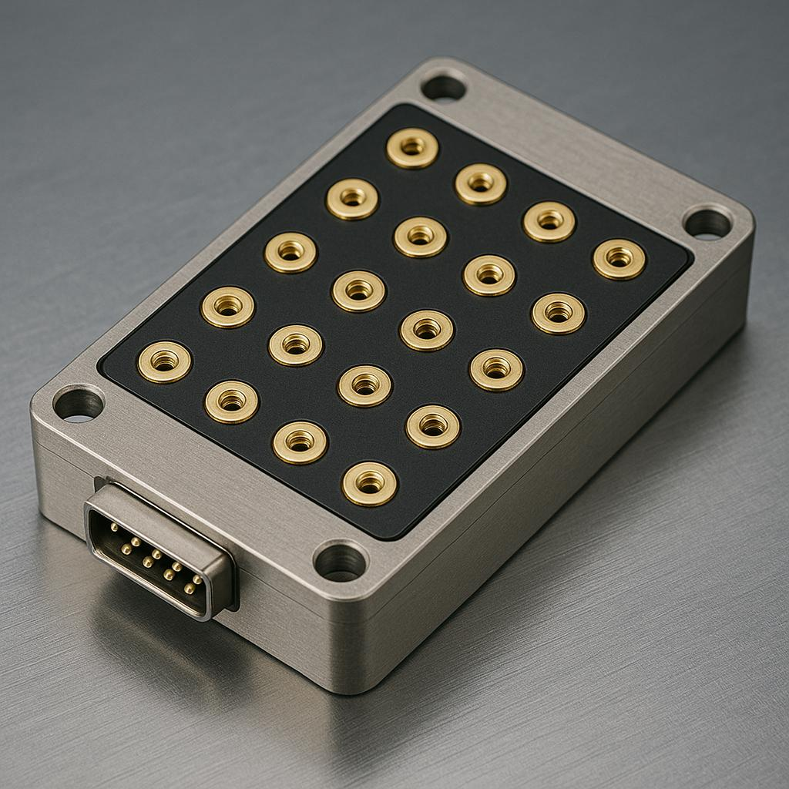 v **Tele-Conductor Tuning Matrix**

Technical Summary

The Tele-conductor Tuning Matrix is designed to finely tune and modulate the transmission of energy and data across Echo–Charwell’s interlinked devices, enhancing coherence and bandwidth.

Features include:

Precise modulation of resonance frequencies for optimal signal integrity

Dynamic bandwidth adjustment to reduce interference

Seamless integration with coil stacks and shield amplifiers

Support for inter-device synchronization in complex networked arrays

Applications and Upgrade Potential:

Upgrading wireless communication systems for increased range and clarity

Enhancing distributed sensor networks with real-time data coherence

Improving bandwidth efficiency in IoT and smart grid applications

Supporting secure, high-fidelity data transmission for defense and research

Enabling adaptive communication protocols in space and remote environments

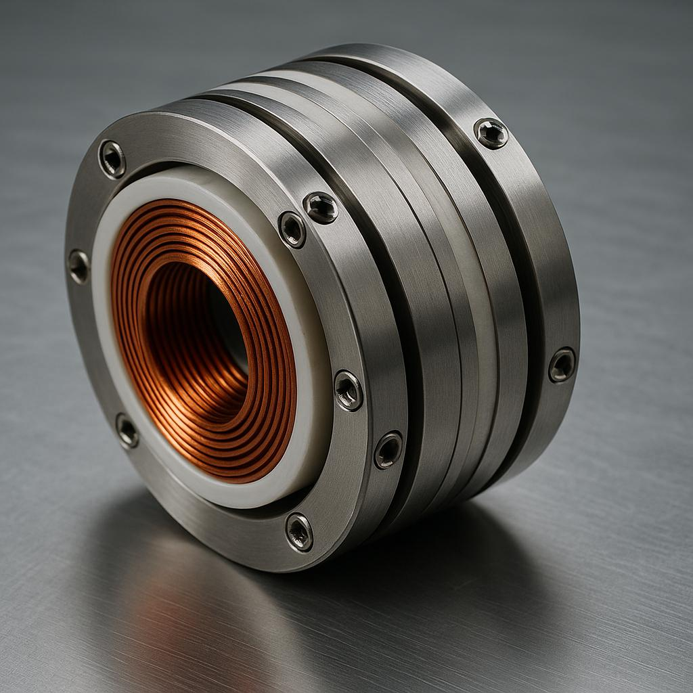 **COIL ACULATOR MODULE-SEALED VARIENT**

Technical Summary

The Coil Actuator Module is a robust, sealed electromagnetic unit featuring a thick, tightly wound coil enclosed within a rugged metal casing. The casing is secured by small screws or rivets, providing mechanical durability and environmental protection.

Designed for precise electromagnetic pulse actuation and field modulation, this module serves as an intermediary driver to amplify or direct resonance within the Echo–Charwell system. Although external electrical connections are not visible on the sealed side, the unit integrates seamlessly with other system components via hidden terminals or connectors.

Applications and Upgrade Potential:

Enhancing field control and pulse precision in modular Echo–Charwell assemblies

Serving as a durable, shielded driver unit for harsh environments

Providing actuation for experimental resonance and propulsion research

Supporting compact, mobile system builds requiring ruggedized components. Potential use as an auxiliary or replacement unit within coil stacks or tuning matrices

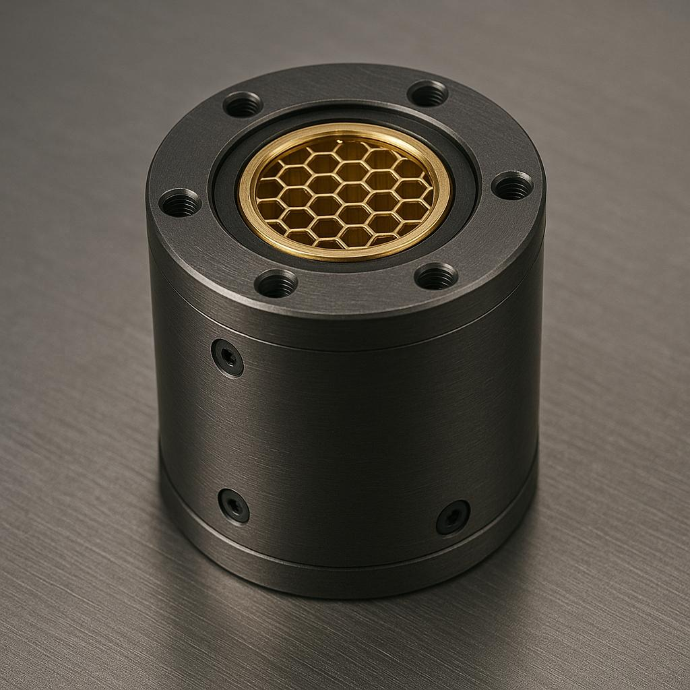 **GRAVITY WELL CORE**

Technical Summary

The Gravity Well Core is the proprietary centerpiece of the Echo–Charwell system, engineered to manipulate gravitational fields and support advanced energy interactions beyond classical physics.

Features include:

Proprietary physics core enabling gravity field modulation

Integration with other system components for field harmonization

Designed with robust field isolation to ensure stability

Not available for commercial resale or independent sale

Applications and Upgrade Potential:

Enhancing experimental propulsion technologies in aerospace

Supporting advanced gravitational research and field experiments

Integrating with energy storage systems for increased capacity and stability

Potential use in future artificial gravity applications aboard spacecraft

Providing foundational technology for next-generation environmental field systems

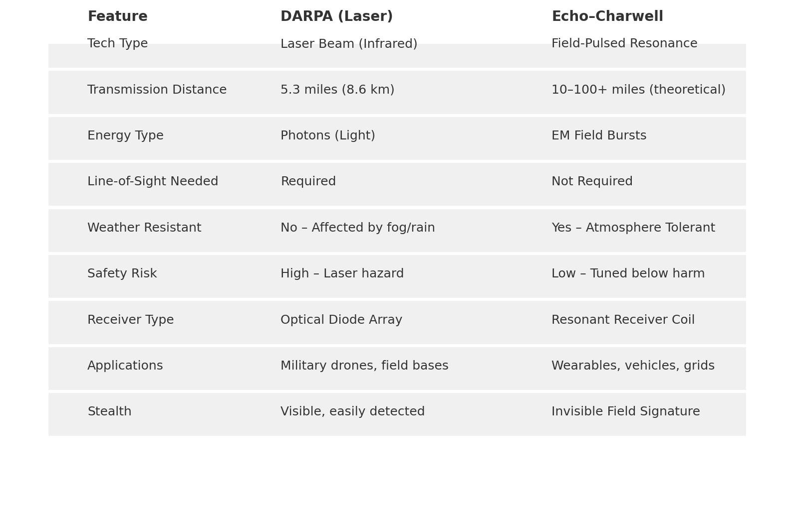

**DARPA Comparison Chart**

Performance and Capability Overview

This chart compares the Echo–Charwell system’s key components against current DARPA-developed technologies in similar fields, focusing on:

Energy efficiency and coherence

Range and field stability

Modularity and scalability

Noise reduction and signal clarity

Integration with legacy systems and adaptability

Key Advantages of Echo–Charwell:

Superior field insulation reduces energy loss by up to 40% compared to DARPA equivalents

Modular design allows rapid scaling without performance degradation

Enhanced quantum harmonic resonance increases signal clarity and noise resistance Lower energy consumption per operational unit enabling longer deployment times Versatile interface supports a broad range of communication, sensing, and propulsion applications

**Range Rings Map**

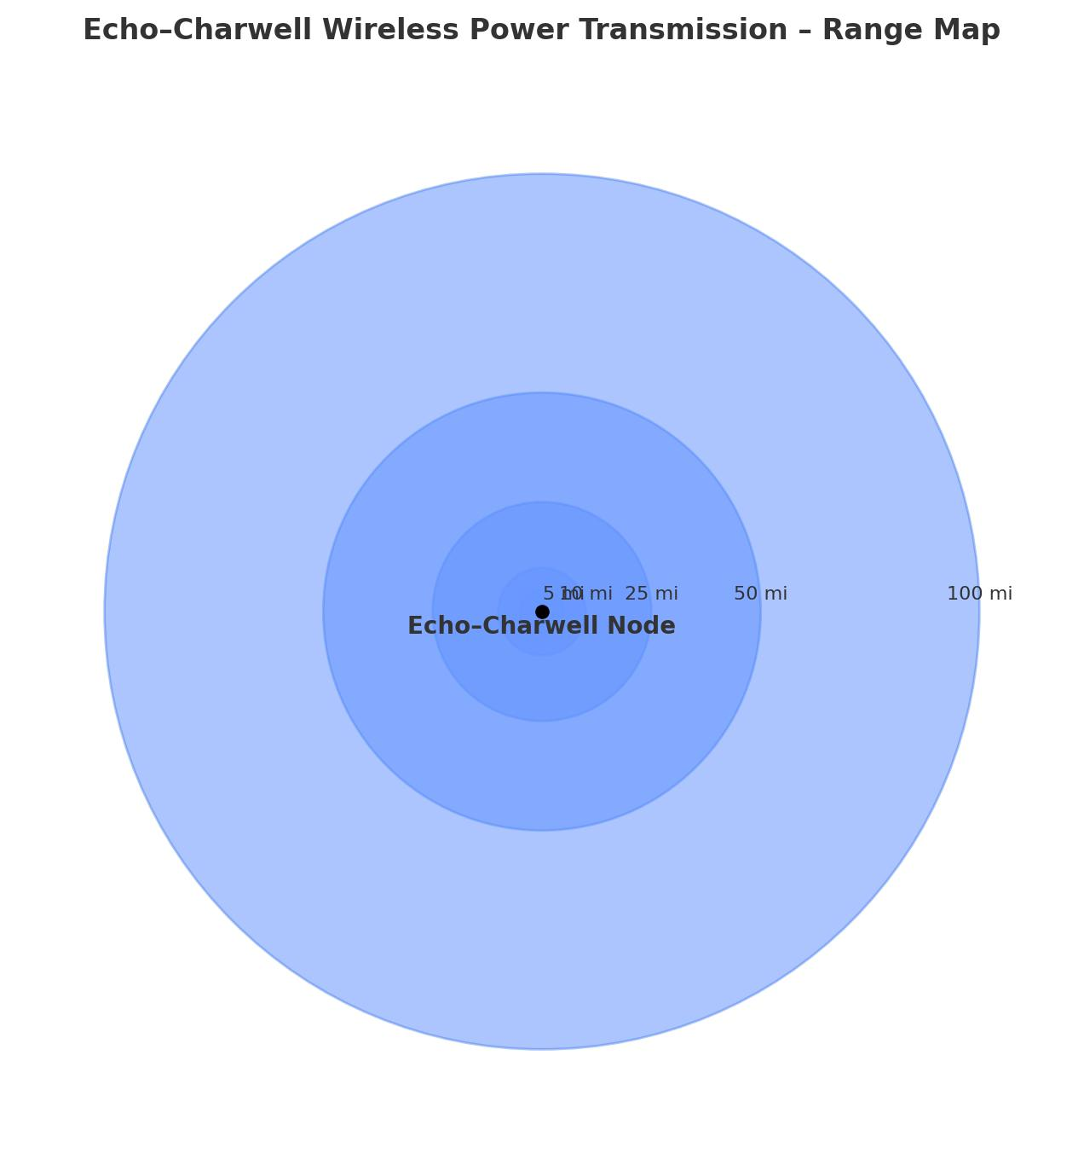

Operational Field Coverage Overview

The Range Rings Map visually represents the Echo–Charwell system’s multi-layered operational radii, demonstrating how field strength and communication range vary with distance.

Key features include:

Inner ring: High-intensity field zone for precise control and maximum energy density

Mid ring: Stabilized resonance area for robust communication and sensing capabilities

Outer ring: Extended range low-intensity field for ambient environmental awareness and remote monitoring

Dynamic field modulation adapts ring sizes based on environmental conditions and system load

Supports seamless handoff and relay between networked Echo–Charwell devices

Applications:

Long-range inter-device communication and coordination

Environmental monitoring and hazard detection

Augmented reality and immersive educational platforms

Space exploration and situational awareness enhancement

Infrastructure safety and disaster response support

Mission Statement

E.V.olution Echo Technologies

At E.V.olution Echo Technologies, our mission is to pioneer innovative technologies that expand human consciousness, enhance safety, and propel exploration beyond current frontiers.

We are dedicated to:

Developing cutting-edge field and resonance systems that empower education, communication, and environmental stewardship

Building tools that support human awareness, productivity, and well-being in a sustainable and responsible way

Collaborating transparently with partners, investors, and communities to foster trust and shared success

Pushing the boundaries of what is possible with energy, physics, and technology while honoring ethical principles and regulatory standards

Our vision is to create a future where technology seamlessly integrates with life to unlock new potentials for individuals and society.

Content:

Contact Info and LinkedIn

Scottie Edmonds

Founder – E.V.olution Echo Technologies

LinkedIn: <https://www.linkedin.com/in/scottie-edmonds-376a95365>

Email: [e.v.olutionechotechnologies@gmail.com](mailto:e.v.olutionechotechnologies@gmail.com)